Lewis University
CPSC 50900: Database Systems
Spring 2023 Term Project

FASHION STORE DATABASE PROJECT

Hruthasan Mallala
HruthasanMallala@lewisu.edu
GitHub: https://github.com/Hruthasan/FASHION-STORE-DATABASE-PROJECT.git

Table of Contents

- Initial Proposal…………………………………………………………………3
- Data Sources……………………………………………………………………4
- Alternative Ways to Store the Data………………………………………..…...8
- Relational Database Design Process…………………………………………...9
- F. Relational Database Design …………………………………………11
- Data Definition Language (DDL) Scripts…………………………………….16
- Data Manipulation Language Scripts…………………………………………22
- Indexes………………………………………………………………………...25
- Views………………………………………………………………………….26
- Triggers…………………………………………………………………...…...27
- Transactions…………………………………………………………………...29
- M. Database Security ………………………………………………………...31
- Locking and Concurrent Access……………………………………………...33
- Backing Up Your Database………………………………………………….34
- Programming…………………………………………………………………35
- Suggested Future Work………………………………………………………37
- Activity Log………………………………………………………………….40

Initial Proposal
I've developed a website where I sell clothing. Customers of this company purchase clothing from several outlets throughout the city. Customers can purchase the clothes they want from several merchants nearby after registering their stores in the program. Customers, store owners, and shipping partners can register and enter their information on a separate sign-up portal for this app.
I'll be keeping track of customer information, store information, product information, order information, and supply chain information.
I'll be gathering customer information so that I have accurate records of my clients and can estimate the reach of my app inside the city.
I can search the capacity of the warehouse using supply chain information that will be manually input and updated on a regular basis by the staff. The customer's order will immediately create the shipping information. The employee will enter the warehouse location. The delivery partner will enter his information when he signs up.
-Consumers may use the order, shop, and product data. From the list of available products, customers can choose any item from a number of retailers. To verify the status of his deliveries, he can use order data. Workers can update any product, edit it, add discounts to the product, and use order data to pack and dispatch the product to the consumer by using product data.
Using customer information, any mega sale may be planned depending on customers' desire for discounts. Also, I may inform them about offers and discounts using their personal information. In order to run my business, I will use store data. For instance, if a new store opens or signs up for my application from a new location, I can grow my business.
Product data will be utilized to keep track of a product's availability, track its cost, compute its sale based on the sale of another product, and provide a discount for that product. I may evaluate my company using the product inventory.
-Order data will be kept on file to keep track of any order-related information and to monitor the order's total sales.
Data from the supply chain will be stored on delivery partners, warehouse information, and storage capacity. This data will be used to check warehouse capacity, shipping status, and return tracking.
The system will automatically generate each ID.

Data Sources
Every time a user or customer logs into my program, I employ a universally unique identifying method to generate a Unique ID. When a customer registers up, he provides his name, address, and phone number, which are all stored in the customer entity.
The employee will manually enter the product details. Given that this application only covers a tiny area. I intend to manually enter the following information: product name, brand, cost, size, and material.
The owner of the shop must register for an application through a different portal supplied in the application.
The seller will submit the address, store name, and other store-related information when registering, and an exclusive store ID will be generated immediately.
Data pertaining to the delivery partner is contained in the supply chain. The employee will manually enter the information for the delivery partner. The delivery person will receive an automatically produced unique ID.
The employee will add information about the warehouse, such as its address and storage capacity.
Details about the delivery person, like their name, phone number, and vehicle identification number, can also be included here. Once an order is placed, an automated Order ID will be produced. Order quantity and order information are produced at the time of purchase.
- Customer Data
This file contains information about the fashion store's customers. Customer ID, name, contact information (phone number and email address), shipping and billing addresses, and order history are all included. This information could have come through online registrations, in-store transactions, or third-party sources. The data could be formatted as CSV (Comma Separated Value) or Excel.
Data fields and their types:
- Customer ID: unique identifier (integer)
- Name(string)
- Phone Number(string)
- Email Address(string)
- Shipping Address(string)
- Billing Address(string)
- Order History(string)
Constraints:
- Customer ID must be unique and not null
- Phone number and email address must be valid and unique
- Shipping and billing addresses cannot be null
- Product Data:
This file contains information on the fashion store's products. Product ID, name, description, brand, category, price, and quantity in stock are all included. The data could be received from suppliers or internally through product development.
Data fields and their types:
Product ID: unique identifier (integer)
Name(string)
Description(string)
Brand(string)
Category(string)
Price: decimal
Quantity in Stock: integer
Constraints:
Product ID must be unique and not null
Price must be a positive number
Quantity in stock cannot be negative
- Store data
This file contains information on the fashion store's physical locations. It contains information such as the store ID, name, address, phone number, and manager's name. The information could come from internal company records or from other sources.
Data fields and their types:
Store ID: unique identifier (integer)
Name: (string)
Address: (string)
Phone Number(string)
Manager's Name(string)
Constraints:
Store ID must be unique and not null
Phone number must be valid and unique
Address cannot be null
- Delivery Partner data:
This file offers information about the fashion store's delivery partners. It contains information such as the partner ID, name, contact information, and service area. The data could be collected from the employees itself while they are joining the firm.
Data fields and their types:
Partner ID: unique identifier (integer)
Name(string)
Contact Information(string)
Service Area:(string)
Constraints:
Partner ID must be unique and not null
Contact information must be valid and unique
Service area cannot be null
- Warehouse data:
This file provides details about the fashion store's warehouses. It contains information like warehouse ID, location, and capacity. The information could come from company records or from warehouse owners.
Data fields and their types:
Warehouse ID: unique identifier (integer)
Location: text (string)
Capacity: integer
Constraints:
Warehouse ID must be unique and not null
Capacity cannot be negative
- Order Data
This file includes information about the orders that clients have placed. Order ID, customer ID, product ID, delivery partner ID, store ID, order date, delivery date, and order status are all included.
Data fields and their types:
Order ID: unique identifier (integer)
Order Date: datetime
Delivery Date: datetime
Order Status: text (string)
Customer ID: integer (Foreign key)
Product ID: integer (Foreign key)
Delivery Partner ID: integer (Foreign key)
Store ID: integer (Foreign key)
Constraints:
Order ID must be unique and not null
Customer ID, Product ID, Delivery Partner ID, and Store ID must reference their respective data tables and cannot be null
Order Date and Delivery Date must be valid datetime values
Order Status must be one of a predetermined set of values (e.g., "processing", "shipped", "delivered")

Data Storage Alternatives
Cloud storage now gives users the choice to share and view information remotely without utilizing their local storage systems.
One benefit of cloud storage is:
Without the need for hardware, using external drives is substantially more expensive per GB than cloud storage.
Accessibility: If you store your documents on the cloud, you can get to them from any place with an internet connection.
Recovery: In the event of a hard drive failure or other technical problem, you can access your files in the cloud. The physical drives that make up your local storage can be backup using this option.
Updates are synced and updated across all of your devices whenever you make changes to a file while utilizing cloud storage.
Security: Cloud storage providers make their services more secure.
Cloud storage has the following drawbacks:
Internet connectivity is necessary in order to use cloud storage. If your network is slow, you can have trouble accessing your storage. If there is no internet access where you are, you won't be able to read your files.
Costs: Downloading and uploading data to the cloud incur additional fees. These expenses could add up very quickly if you routinely try to access many files.
drive discs Cloud storage should make us less dependent on hard drives, right? Moreover, some businesses that offer cloud storage also require actual hard discs. Using a free cloud provider prevents you from getting the best cloud storage assistance. Several service providers advise looking through a knowledge base.
- Relational Database Design Process
Functional dependencies that exist among the fields:
- Customer Entity:
Customer ID → Name, Address, Phone Number
  - Determinants: Customer ID
  - Fields they determine: Name, Address, Phone Number
- Product Entity:
Product ID → Product Name, Brand, Cost, Size, Material
  - Determinants: Product ID
  - Fields they determine: Product Name, Brand, Cost, Size, Material
- Store Entity:
Store ID → Store Name, Address
  - Determinants: Store ID
  - Fields they determine: Store Name, Address
- Delivery Partner Entity:
Delivery Partner ID → Name, Phone Number, Vehicle Identification Number
  - Determinants: Unique ID
  - Fields they determine: Name, Phone Number, Vehicle Identification Number
- Warehouse Entity:
Warehouse ID → Address, Storage Capacity
  - Determinants: Warehouse ID
  - Fields they determine: Address, Storage Capacity
- Order Entity:
Order ID → Order Quantity, Order Information
  - Determinants: Order ID
  - Fields they determine: Order Quantity, Order Information
Entity Sets:
- Customer
- Product
- Store
- Delivery Partner
- Warehouse
- Order

Relationships:
1. Customer places Order (one-to-many): A customer can place many orders, but each order is placed by one customer (mandatory participation on both sides).
2. Store sells Product (many-to-many): A store can sell many products and a product can be sold by many stores (mandatory participation on both sides).
3. Order contains Product (many-to-many): An order can contain many products and a product can be part of many orders (mandatory participation on both sides).
4. Warehouse stores Product (one-to-many): A warehouse can store many products, but each product is stored in one warehouse (optional participation on the warehouse side and mandatory participation on the product side).
5. Delivery Partner delivers Order (one-to-many): A delivery partner can deliver many orders, but each order is delivered by one delivery partner (optional participation on the delivery partner side and mandatory participation on the order side).

Breaking Down Multi-Valued Attributes:
There are no multi-valued attributes in the identified functional dependencies.

- Relational Database Design
Normalization analysis of your entity sets:
- Customer Entity:
- The primary key of the Customer entity set is Customer ID, which determines the fields Name, Address, and Phone Number. Therefore, it satisfies the requirements for 2nd normal form (2NF).
- There are no transitive dependencies, so the entity set also satisfies the requirements for 3rd normal form (3NF).
- The entity set is in Boyce-Codd normal form (BCNF).
- Product Entity:
- The primary key of the Product entity set is Product ID, which determines the fields Product Name, Brand, Cost, Size, and Material. Therefore, it satisfies the requirements for 2nd normal form (2NF).
- There are no transitive dependencies, so the entity set also satisfies the requirements for 3rd normal form (3NF).
- The entity set is in Boyce-Codd normal form (BCNF).
- Store Entity:
- The primary key of the Store entity set is Store ID, which determines the fields Store Name and Address. Therefore, it satisfies the requirements for 2nd normal form (2NF).
- There are no transitive dependencies, so the entity set also satisfies the requirements for 3rd normal form (3NF).
- The entity set is in Boyce-Codd normal form (BCNF).
- Delivery Partner Entity:
- The primary key of the Delivery Partner entity set is Delivery Partner ID, which determines the fields Name, Phone Number, and Vehicle Identification Number. Therefore, it satisfies the requirements for 2nd normal form (2NF).
- There are no transitive dependencies, so the entity set also satisfies the requirements for 3rd normal form (3NF).
- The entity set is in Boyce-Codd normal form (BCNF).
- Warehouse Entity:
- The primary key of the Warehouse entity set is Warehouse ID, which determines the fields Address and Storage Capacity. Therefore, it satisfies the requirements for 2nd normal form (2NF).
- There are no transitive dependencies, so the entity set also satisfies the requirements for 3rd normal form (3NF).
- The entity set is in Boyce-Codd normal form (BCNF).
- Order Entity:
- The primary key of the Order entity set is Order ID, which determines the fields Order Quantity and Order Information. Therefore, it satisfies the requirements for 2nd normal form (2NF).
- There are no transitive dependencies, so the entity set also satisfies the requirements for 3rd normal form (3NF).
- The entity set is in Boyce-Codd normal form (BCNF).
Overall, all entity sets are in BCNF, indicating that there are no partial dependencies, transitive dependencies, or candidate keys in the entity sets. Therefore, the database design is free from anomalies that could result in data inconsistency and update anomalies.

Introducing bridge entity sets:
There exits many to many relationship between entities Order and Product, Store and Product. Therefore we introduce bridge entity sets for them as follows:
Order_Product: OrderID (PK/FK) , ProductID (PK/FK), Quantity
Store_Product: StoreID (PK/FK), ProductID (PK/FK), Quantity, Cost

Choosing foreign keys:
- Customer:
- CustomerID (PK)
- Name
- Address
- Phone Number
- Product:
- ProductID (PK)
- Product Name
- Brand
- Cost
- Size
- Material
- WarehouseID (FK)
- Store:
- StoreID (PK)
- Store Name
- Address
- Delivery Partner:
- DeliveryPartnerID (PK)
- Name
- Phone Number
- Vehicle Identification Number
- Warehouse:
- WarehouseID (PK)
- Address
- Storage Capacity
- Order:
- OrderID (PK)
- Order Quantity
- Order Information
- CustomerID (FK)
- DeliveryPartnerID (FK)
- Order_Product:
- OrderID (PK/FK)
- ProductID (PK/FK)
- Quantity
- Store_Product:
- StoreID (PK/FK)
- ProductID (PK/FK)
- Quantity
- Cost
ERD diagram
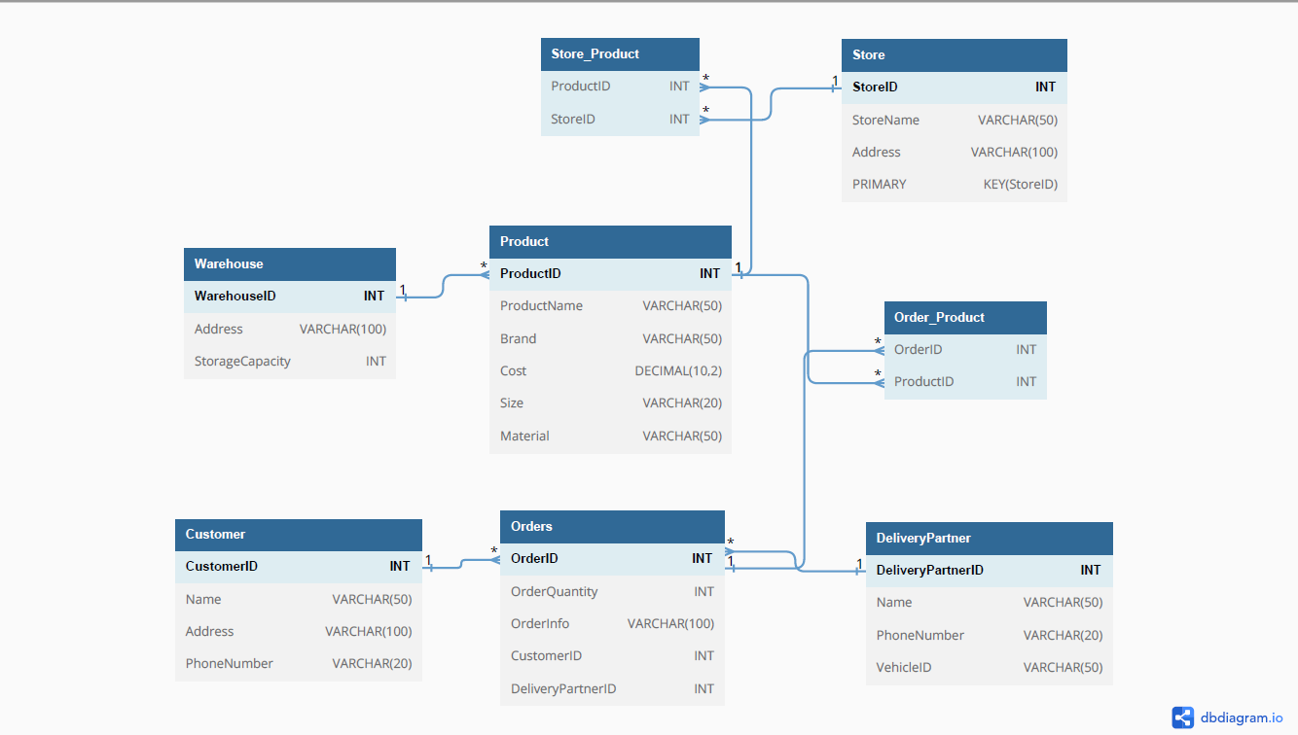
- Data Definition Language Scripts
CREATE DATABASE fashion _store;
USE fashion_store;
CREATE TABLE Customer (
CustomerID INT NOT NULL AUTO_INCREMENT,
Name VARCHAR(50) NOT NULL,
Address VARCHAR(100) NOT NULL,
PhoneNumber VARCHAR(20) NOT NULL,
PRIMARY KEY (CustomerID)
);

CREATE TABLE Product (
ProductID INT NOT NULL AUTO_INCREMENT,
ProductName VARCHAR(50) NOT NULL,
Brand VARCHAR(50) NOT NULL,
Cost DECIMAL(10,2) NOT NULL,
Size VARCHAR(20) NOT NULL,
Material VARCHAR(50) NOT NULL,
PRIMARY KEY (ProductID)
WarehouseID INT NOT NULL,
FOREIGN KEY (WarehouseID) REFERENCES Warehouse(WarehouseID)
);
CREATE TABLE Store (
StoreID INT NOT NULL AUTO_INCREMENT,
StoreName VARCHAR(50) NOT NULL,
Address VARCHAR(100) NOT NULL,
PRIMARY KEY (StoreID)
);

CREATE TABLE DeliveryPartner (
DeliveryPartnerID INT NOT NULL AUTO_INCREMENT,
Name VARCHAR(50) NOT NULL,
PhoneNumber VARCHAR(20) NOT NULL,
VehicleID VARCHAR(50) NOT NULL,
PRIMARY KEY (DeliveryPartnerID)
);

CREATE TABLE Warehouse (
WarehouseID INT NOT NULL AUTO_INCREMENT,
Address VARCHAR(100) NOT NULL,
StorageCapacity INT NOT NULL,
PRIMARY KEY (WarehouseID)
);

CREATE TABLE Order (
OrderID INT NOT NULL AUTO_INCREMENT,
OrderQuantity INT NOT NULL,
OrderInfo VARCHAR(100) NOT NULL,
CustomerID INT NOT NULL,
DeliveryPartnerID INT,
PRIMARY KEY (OrderID),
FOREIGN KEY (CustomerID) REFERENCES Customer(CustomerID),
FOREIGN KEY (DeliveryPartnerID) REFERENCES DeliveryPartner(DeliveryPartnerID)
);

CREATE TABLE Store_Product (
ProductID INT NOT NULL,
StoreID INT NOT NULL,
PRIMARY KEY (ProductID, StoreID),
FOREIGN KEY (ProductID) REFERENCES Product(ProductID),
FOREIGN KEY (StoreID) REFERENCES Store(StoreID)
);

CREATE TABLE Order_Product (
OrderID INT NOT NULL,
ProductID INT NOT NULL,
PRIMARY KEY (OrderID, ProductID),
FOREIGN KEY (OrderID) REFERENCES Order(OrderID),
FOREIGN KEY (ProductID) REFERENCES Product(ProductID)
);

INSERT INTO Customer (CustomerID, Name, Address, PhoneNumber) VALUES
(1, 'John Doe', '123 Main St, Anytown, USA', '555-1234'),
(2, 'Jane Smith', '456 Elm St, Anytown, USA', '555-5678'),
(3, 'Bob Johnson', '789 Oak St, Anytown, USA', '555-9012');

INSERT INTO Product (ProductID, ProductName, Brand, Cost, Size, Material, WarehouseID) VALUES
(1, 'T-Shirt', 'Nike', 19.99, 'M', 'Cotton', 1),
(2, 'Jeans', 'Levi''s', 49.99, '32x32', 'Denim', 2),
(3, 'Running Shoes', 'Adidas', 89.99, '10', 'Synthetic', 1);

INSERT INTO Store (StoreID, StoreName, Address) VALUES
(1, 'Anytown Mall', '100 Mall Rd, Anytown, USA'),
(2, 'Downtown Outlet', '50 Main St, Anytown, USA'),
(3, 'Suburban Plaza', '200 Elm St, Anytown, USA');

INSERT INTO DeliveryPartner (DeliveryPartnerID, Name, PhoneNumber, VehicleID) VALUES
(1, 'John Smith', '555-1111', 'ABC123'),
(2, 'Jane Doe', '555-2222', 'DEF456'),
(3, 'Bob Williams', '555-3333', 'GHI789');

INSERT INTO Warehouse (WarehouseID, Address, StorageCapacity) VALUES
(1, '1000 Industrial Pkwy, Anytown, USA', 1000),
(2, '2000 Commerce Blvd, Anytown, USA', 2000),
(3, '3000 Business St, Anytown, USA', 1500);

INSERT INTO Order (OrderID, OrderQuantity, OrderInfo, CustomerID, DeliveryPartnerID) VALUES
(1, 2, 'Order for John Doe', 1, 1),
(2, 1, 'Order for Jane Smith', 2, NULL),
(3, 3, 'Order for Bob Johnson', 3, 3);

INSERT INTO Store_Product (ProductID, StoreID) VALUES
(1, 1),
(2, 1),
(3, 2),
(1, 3);

INSERT INTO Order_Product (OrderID, ProductID) VALUES
(1, 1),
(1, 2),
(2, 3),
(3, 1),
(3, 2),
(3, 3);

"create_tables.sql": This script creates the necessary tables for our database schema. It includes the creation of six entity tables (Customer, Product, Store, DeliveryPartner, Warehouse, Order) and two relationship tables (Store_Product, Order_Product).
E.g.
CREATE TABLE Customer (
CustomerID INT NOT NULL AUTO_INCREMENT,
Name VARCHAR(50) NOT NULL,
Address VARCHAR(100) NOT NULL,
PhoneNumber VARCHAR(20) NOT NULL,
PRIMARY KEY (CustomerID)
);
"populate_tables.sql": This script populates the tables created in the "create_tables.sql" script with sample data. It adds at least three records to each table.
E.g.
INSERT INTO Customer (CustomerID, Name, Address, PhoneNumber) VALUES
(1, 'John Doe', '123 Main St, Anytown, USA', '555-1234'),
(2, 'Jane Smith', '456 Elm St, Anytown, USA', '555-5678'),
(3, 'Bob Johnson', '789 Oak St, Anytown, USA', '555-9012');

- Data Manipulation Language Scripts
- Insert statement for adding a new customer:
INSERT INTO Customer (Name, Address, PhoneNumber)
VALUES ('John Doe', '123 Main St', '555-555-5555');

- Insert statement for adding a new product:
INSERT INTO Product (ProductName, Brand, Cost, Size, Material, WarehouseID)
VALUES ('T-shirt', 'Nike', 19.99, 'Large', 'Cotton', 1);

- Update statement for changing the address of a customer:
UPDATE Customer
SET Address = '456 Elm St'
WHERE CustomerID = 1;
- Update statement for changing the price of a product:
UPDATE Product
SET Cost = 24.99
WHERE ProductID = 1;
- Delete statement for removing a customer:
DELETE FROM Customer
WHERE CustomerID = 2;
- Simple select statement for retrieving the name and phone number of all customers:
SELECT Name, PhoneNumber
FROM Customer;
- Joining two tables to retrieve the products sold by a specific store:
SELECT Product.ProductName, Product.Brand, Product.Cost
FROM Product
INNER JOIN Store_Product ON Product.ProductID = Store_Product.ProductID
INNER JOIN Store ON Store_Product.StoreID = Store.StoreID
WHERE Store.StoreName = 'Target';
- Joining two tables to retrieve the orders placed by a specific customer:
SELECT Order.OrderID, Order.OrderQuantity, Order.OrderInfo, Product.ProductName
FROM Order
INNER JOIN Order_Product ON Order.OrderID = Order_Product.OrderID
INNER JOIN Product ON Order_Product.ProductID = Product.ProductID
WHERE Order.CustomerID = 1;
- Summary function to retrieve the total cost of all orders:
SELECT SUM(Order.OrderQuantity * Product.Cost) AS TotalCost
FROM Order
INNER JOIN Order_Product ON Order.OrderID = Order_Product.OrderID
INNER JOIN Product ON Order_Product.ProductID = Product.ProductID;
- Summary function to retrieve the average cost of products by brand:
SELECT Product.Brand, AVG(Product.Cost) AS AvgCost
FROM Product
GROUP BY Product.Brand;
- Multi-table query to retrieve the products stored in a specific warehouse:
SELECT Product.ProductName, Product.Size, Warehouse.StorageCapacity
FROM Product
INNER JOIN Warehouse ON Product.WarehouseID = Warehouse.WarehouseID
WHERE Warehouse.WarehouseID = 1;
- Query to retrieve the top 5 best-selling products:
SELECT Product.ProductName, COUNT(*) AS SalesCount
FROM Product
INNER JOIN Order_Product ON Product.ProductID = Order_Product.ProductID
GROUP BY Product.ProductName
ORDER BY SalesCount DESC
LIMIT 5;

- Index:

- Composite index on Order table for CustomerID and DeliveryPartnerID:
SQL Query:
CREATE INDEX indx_order_customer_deliverypartner ON Orders (CustomerID, DeliveryPartnerID);
This index would be useful when querying orders by customer or delivery partner. It would allow for faster retrieval of orders for a particular customer or delivery partner, reducing the need for full table scans.
- Index on the Product table on the WarehouseID column:
SQL Query:
CREATE INDEX indx_product_warehouse_id ON Product (WarehouseID);
This index would be useful when querying products by warehouse.The warehouse data is frequently accessed along with the product data. . It would allow for faster retrieval of products for a specific warehouse, reducing the need for full table scans.

- Composite index on the Order_Product table on the OrderID and ProductID columns:
SQL Query:
CREATE INDEX indx_order_product ON Order_Product (OrderID, ProductID);
This index will help speed up queries that involve searching for all products associated with a specific order. It would allow for faster retrieval of products, reducing the need for full table scans.

To demonstrate the impact of these indexes on the performance of various queries, I would run before-and-after benchmarks on a set of representative queries.
For example:
>> SELECT * FROM Orders WHERE CustomerID = 1 AND DeliveryPartnerID = 3;
>> SELECT * FROM Product WHERE WarehouseID = 456;
>> SELECT * FROM Order_Product
JOIN Order ON Order_Product.OrderID = Order.OrderID
WHERE Order.CustomerID = 1;

- Views:
- CREATE VIEW Order_Customer_Info AS
SELECT Order.OrderID, Order.OrderQuantity, Order.OrderInformation, Customer.Name, Customer.Address, Customer.PhoneNumber
FROM Order
INNER JOIN Customer ON Order.CustomerID = Customer.CustomerID;
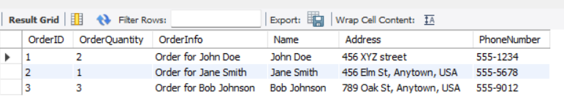
This view combines data from the Order and Customer tables, allowing for easy access to order information along with customer information. This can be useful when analyzing orders and customer behaviour.
- CREATE VIEW StoreInventory AS
SELECT s.StoreID, s.StoreName, s.Address AS StoreAddress, p.ProductID, p.ProductName, p.Brand, p.Cost, p.Size, p.Material, sp.Quantity
FROM Store s
JOIN Store_Product sp ON s.StoreID = sp.StoreID
JOIN Product p ON sp.ProductID = p.ProductID;
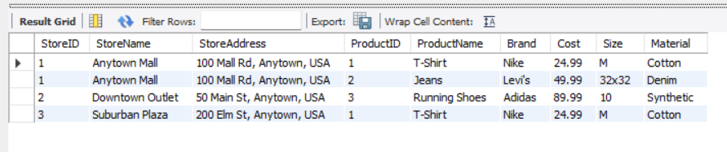
This view combines data from the Store, Store_Product, and Product tables, providing a comprehensive overview of the inventory at each store.
These views are valuable additions to the database because they provide an easy way to access and combine information from multiple tables. They can be used to quickly get a comprehensive overview of the order details and store inventory in a single view, which can be useful for various tasks such as inventory management, order tracking, and reporting.

- Triggers:
DELIMITER $$
CREATE TRIGGER trg_product_added
AFTER INSERT ON Product
FOR EACH ROW
BEGIN
UPDATE Warehouse
SET StorageCapacity = StorageCapacity + NEW.Size
WHERE Warehouse.WarehouseID = NEW.WarehouseID;
END$$
DELIMITER ;
The purpose of this trigger is to update the StorageCapacity of the Warehouse table whenever a new product is added to the Product table. The trigger fires after a new row is inserted into the Product table and retrieves the size of the new product (NEW.Size) and the corresponding WarehouseID (NEW.WarehouseID). It then updates the StorageCapacity of the Warehouse with the corresponding WarehouseID by adding the size of the new product to the current value.

INSERT INTO Product (ProductName, Brand, Cost, Size, Material, WarehouseID)
VALUES ('Charger', 'Samsung', 1000, 15, 'Aluminum', 1);-
Before trigger:
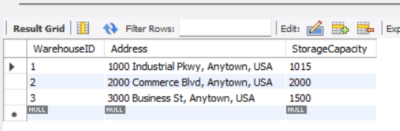
After trigger:
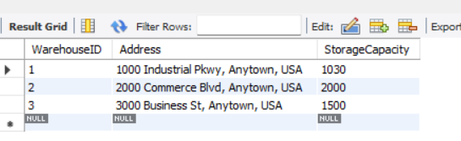

- Transactions:
Transactions are important for ensuring ACID behavior, which stands for Atomicity, Consistency, Isolation, and Durability.
Atomicity ensures that a transaction is treated as a single unit of work, which either completes in its entirety or is rolled back to its previous state if any part of it fails. Consistency ensures that the database remains in a consistent state before and after a transaction, regardless of whether the transaction succeeds or fails. Isolation ensures that multiple transactions can be executed simultaneously without interfering with each other. Durability ensures that once a transaction is committed, its effects persist even if there is a system failure.
Here is an example of a MySQL transaction:
START TRANSACTION;
UPDATE Product
SET Cost = 1200
WHERE ProductID = 1;
UPDATE Warehouse
SET StorageCapacity = StorageCapacity - 10
WHERE WarehouseID = 1;
COMMIT;
Before Transaction:
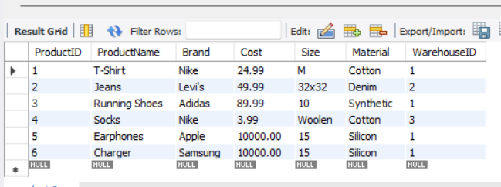
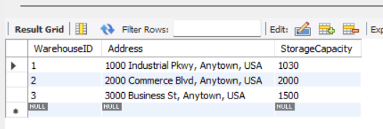
After Transaction:
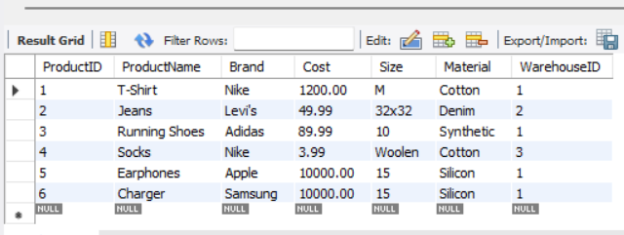
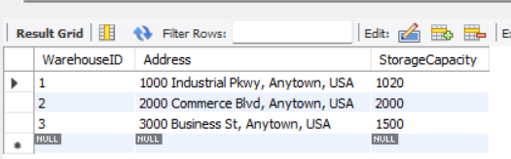
As we can see, the cost of the product with ProductID 1 has been updated to 1200, and the StorageCapacity of the warehouse with WarehouseID 1 has been reduced by 10. These changes were made atomically and consistently, and the transaction was isolated from any other transactions that may have been running concurrently. Finally, the effects of the transaction are durable and will persist even in the event of a system failure.
- Security:
Based on the design of the database, there are several types of users who may use the database:
- System administrators - They will have complete control over the database.
- Warehouse managers - They will be responsible for managing the inventory stored in the warehouse.
- Store managers - They will be responsible for managing the inventory and orders for their store.
- Delivery partners - They will be responsible for delivering the orders to customers.
- Customers - They will be able to view their order history and personal information
System Administrators:
CREATE USER 'sysadmin'@'localhost' IDENTIFIED BY 'mkyt1234';
GRANT ALL PRIVILEGES ON *.* TO 'sysadmin'@'localhost';
This statement grants all privileges on all databases to the user 'sysadmin' on the local machine.
Warehouse Managers:
CREATE USER 'warehouse_mgr'@'localhost' IDENTIFIED BY 'mkyt123';
GRANT SELECT, INSERT, UPDATE ON Product TO 'warehouse_mgr'@'localhost';
GRANT SELECT, INSERT, UPDATE ON warehouse TO 'warehouse_mgr'@'localhost';
GRANT SELECT, INSERT, UPDATE ON order_product TO 'warehouse_mgr'@'localhost';
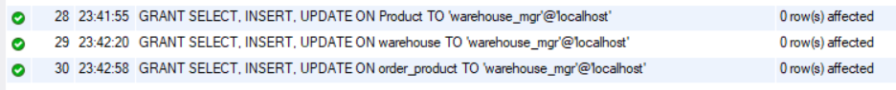
This statement grants the user 'warehouse_mgr' on the local machine the privileges to select, insert, and update data in the Product, Warehouse, and Order_Product tables.
Store Managers:
CREATE USER 'store_mgr'@'localhost' IDENTIFIED BY 'mkyt12';
GRANT SELECT, INSERT, UPDATE ON Product TO 'store_mgr'@'localhost';
GRANT SELECT, INSERT, UPDATE ON Store_Product TO 'store_mgr'@'localhost';
GRANT SELECT, INSERT, UPDATE ON Orders TO 'store_mgr'@'localhost';
GRANT SELECT, INSERT, UPDATE ON Order_Product TO 'store_mgr'@'localhost';
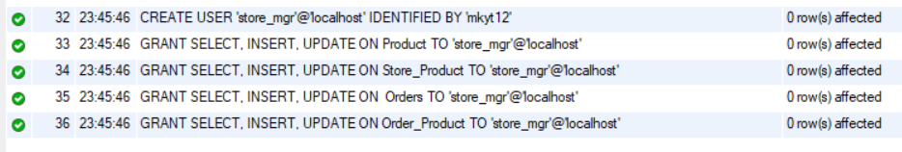
This statement grants the user 'store_mgr' on the local machine the privileges to select, insert, and update data in the Product, Store_Product, Order, and Order_Product tables.
Delivery Partners:
CREATE USER 'delivery_partner'@'localhost' IDENTIFIED BY 'mkyt1';
GRANT SELECT, UPDATE ON Orders TO 'delivery_partner'@'localhost';
GRANT SELECT, UPDATE ON Customer TO 'delivery_partner'@'localhost';
This statement grants the user 'delivery_partner' on the local machine the privileges to select and update data in the Order and Customer tables.
Customers:
CREATE USER 'customer'@'localhost' IDENTIFIED BY 'mkyt2';
GRANT SELECT ON Customer TO 'customer'@'localhost';
GRANT SELECT ON Orders TO 'customer'@'localhost';
This statement grants the user 'customer' on the local machine the privilege to select data in the Order and Customer tables.
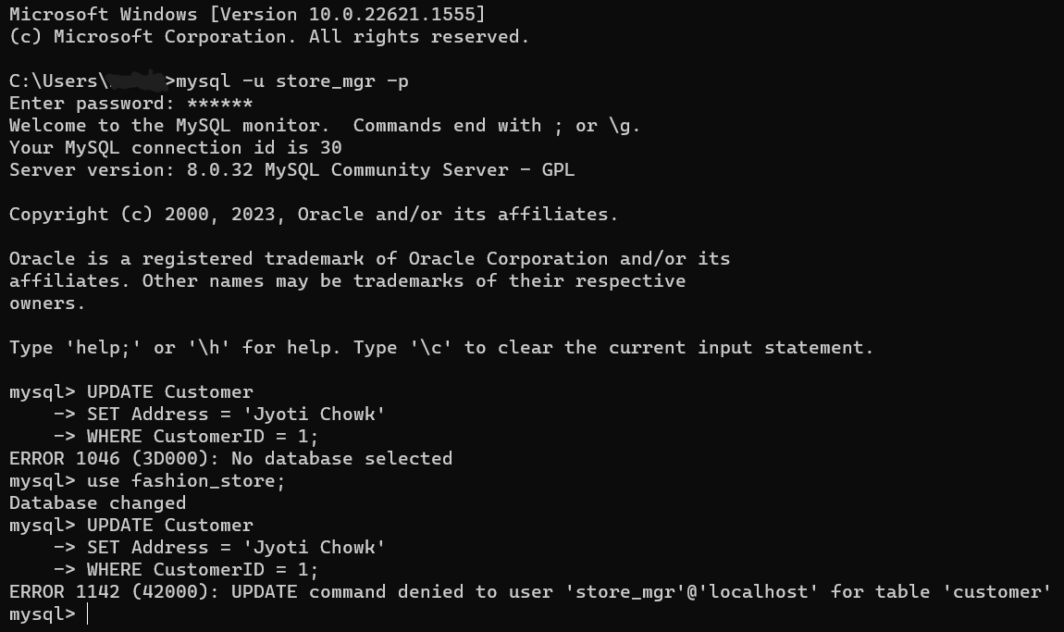
- Locking:
Locking tables is a way to prevent inconsistencies in data that can arise when multiple concurrent transactions are modifying the same data simultaneously. When a table is locked, other transactions are not able to modify it until the lock is released. This ensures that each transaction has exclusive access to the data it needs to modify, which helps prevent race conditions and other issues.
For example, imagine a situation where two users are trying to modify the same row in a table simultaneously. Without locking, it's possible that one user's changes could overwrite the other's, resulting in inconsistent data. By locking the table, we can ensure that only one transaction is able to modify the data at a time, preventing this kind of inconsistency.
It's important to note that locking tables can have performance implications, as it can reduce concurrency and increase the time that transactions have to wait for locks to be released. As such, it's generally a good idea to use locking sparingly and only when necessary to prevent inconsistencies
use fashion_store;
LOCK TABLES deliverypartner READ;
DROP TABLE deliverypartner;
UNLOCK TABLES;
- Backup:
Using MySQL, we can use the `mysqldump` command to create a backup of our database. Here is an example of how you can use this command:
We can also create a script that runs this command and schedule it to run at specific times using tools like cron (on Linux) or Task Scheduler (on Windows) to automate the backup process.
To schedule a backup using Task Scheduler on Windows, we can follow these steps:
1. Open the Task Scheduler by searching for it in the Start menu.
2. In the Task Scheduler, click on "Create Basic Task" in the Actions pane on the right.
3. Follow the wizard to create a new task. Give the task a name and description, and choose when you want the task to start and how often you want it to run.
4. When prompted for the action to perform, choose "Start a program".
5. In the "Program/script" field, enter the path to the `mysqldump` command. This is usually located in the `bin` directory of your MySQL installation (e.g., `C:\Program Files\MySQL\MySQL Server 8.0\bin\mysqldump.exe`).
6. In the "Add arguments" field, enter the arguments for the `mysqldump` command as explained in my previous message (e.g., `-u [username] -p[password] [database_name] > [backup_file.sql]`).
7. Complete the wizard to create the task.
Once the task is created, it will run automatically at the specified times and create a backup of your database using the `mysqldump` command. The frequency at which the backup commands will run depends on how often we schedule the task in Task Scheduler. When creating a new task in Task Scheduler, we can choose when we want the task to start and how often we want it to run. For example, we can choose to run the task daily, weekly, monthly, or at a specific time.
Securing database backups is important to prevent unauthorized access and ensure the integrity of your data. Here are some steps we can take to secure backups:
1. Encrypt backups: Encrypting backups ensures that the data is protected and can only be accessed by someone with the encryption key. We can use tools like `openssl` or `gpg` to encrypt and decrypt backup files.
2. Store backups in a secure location: Store backups in a secure location that is separate from the database server and has restricted access. This can be on a different physical server, on a network-attached storage device, or in the cloud. Make sure that access to the backup location is restricted to only authorized personnel.
3. Use secure transfer methods: When transferring backup files over a network, use secure transfer methods such as `scp` or `sftp` to ensure that the data is encrypted during transit.
4. Monitor and audit backup activity: Regularly monitor and audit backup activity to ensure that backups are being created and stored as expected. This can help detect any issues or unauthorized access to our backups.
- Python Programming
Code:
import mysql.connector

# Establish a connection to the database
mydb = mysql.connector.connect(
host="localhost",
user="root",
password="mandeep",
database="fashion_store"
)

# Create a cursor to execute queries
mycursor = mydb.cursor()

# Write a SQL query to retrieve data from a table
mycursor.execute("SELECT * FROM orders")

# Retrieve the result set
myresult = mycursor.fetchall()

# Open a file to write the report to
with open("report.txt", "w") as f:
# Write a header row
f.write("ID\tName\tAddress\tPhone\n")

# Loop through the result set and write each row to the file
for row in myresult:
f.write(f"{row[0]}\t{row[1]}\t{row[2]}\t{row[3]}\n")

# Close the database connection
mydb.close()

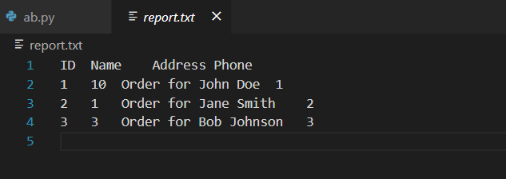

- Suggested Future Work
Limitations:
1. Limited data validation and integrity: There maybe possibility that database design does not include appropriate validation rules and constraints, it may be possible for inaccurate or inconsistent data to be entered into the database. This can lead to errors and inconsistencies that can affect the reliability and usefulness of the data.
2. Limited scalability: As the amount of data stored in database grows, it may become increasingly difficult to maintain acceptable levels of performance and responsiveness. If database design does not take scalability into account, you may encounter performance issues as the database grows.
3. Limited security: Database design does not include appropriate access controls and encryption mechanisms; it may be vulnerable to unauthorized access and data breaches. This can result in the loss or theft of sensitive data, which can have serious consequences for your business.
Methods to address shortcomings:
1. Implement data validation and integrity: To ensure that the data stored in the database is accurate and consistent, we can implement appropriate validation rules and constraints. For example, we can use `CHECK` constraints to enforce data validation rules or `UNIQUE` constraints to prevent duplicate data. We can also use foreign key constraints to ensure referential integrity between related tables.
2. Design for scalability: To improve the scalability of the database, we can design it with scalability in mind from the beginning. This can include using techniques such as indexing, partitioning, or sharding to improve query performance and scalability. We can also consider using a cloud-based database service that can be easily scaled up or down to meet changing demand.
3. Implement strong security measures: To secure the database and protect against unauthorized access, we can implement strong access controls and encryption mechanisms. For example, we can use role-based access control to restrict access to sensitive data based on user roles and permissions. We can also encrypt data at rest and in transit to protect it from unauthorized access.
Migrating the database to the cloud involves moving the data and database infrastructure from local environment to a cloud-based service. This can be done using various tools and methods depending on the specific cloud service provider and database management system.
Here are some general steps that can be followed to migrate a database to the cloud:
1. Choose a cloud service provider: Selecting a cloud service provider that offers a database service that is compatible with the current database management system. Some popular cloud service providers include Amazon Web Services (AWS), Microsoft Azure, and Google Cloud Platform (GCP).
2. Prepare the data: Before migrating the data to the cloud, we may need to prepare it by cleaning, transforming, or reformatting it to meet the requirements of the cloud-based database service.
3. Export the data: Export the data from current database using a tool or method that is compatible with both current database management system and the cloud-based database service. This could involve creating a backup or dump of the data or using a data migration tool provided by the cloud service provider.
4. Import the data: Import data into the cloud-based database service using the tools and methods provided by the cloud service provider. This could involve uploading data to a storage service and then importing it into the database or using a data migration tool to transfer the data directly.
5. Test and verify: After migrating the data to the cloud, test and verify that it has been transferred correctly and that all functionality is working as expected. This could involve running queries, checking data integrity, and testing application functionality.
Here are some advantages and disadvantages of using a document-based NoSQL format:
Advantages:
- Flexibility: Document-based NoSQL databases are schema-less, meaning that we can store data without having to define a fixed schema beforehand. This allows us to easily add new data or change the structure of the data without having to modify the database schema.
- Scalability: Document-based NoSQL databases are designed to scale horizontally, meaning that we can easily add more servers to handle increased demand. This can make it easier to handle large amounts of data and support a growing user base.
- Performance: Document-based NoSQL databases can provide fast read and write performance, especially when dealing with unstructured or semi-structured data. This can make them well-suited for handling real-time data or supporting high-throughput applications.
Disadvantages:
- Data consistency: Document-based NoSQL databases do not provide the same level of data consistency and integrity as relational databases. This means that we may need to implement additional application logic or use other techniques to ensure that data is consistent and accurate.
- Complexity: Document-based NoSQL databases can be more complex to work with than relational databases, especially when it comes to querying and aggregating data. We may need to learn new query languages or use specialized tools to work with your data.
- Limited support for transactions: Document-based NoSQL databases may not provide the same level of support for transactions as relational databases. This means that we may need to implement additional application logic or use other techniques to ensure that data is updated atomically.
- Activity log
When though of starting a project, on 14th of March 2023, got an idea of establishing online clothing store.
03/16/2023, arrived at naming the Online store as “Fashion Store database project”.
03/19/2023, worked on Initial proposal of my business.
03/22/2023, researched about the type of data that should be chosen for maintaining the store.
03/24/2023, researched to find out the different ways to store data.
03/26/2023, Selected an alternative data storage, researched pros and cons.
03/27/2023, worked on project report.
04/02/2023, Done Relational Database Design Process
04/03/2023, Have worked on Relational Database Design
04/04/2023, Have done Relational Database Design
04/07/2023, have written Data Definition Language Scripts
04//08/2023, Have done data manipulation language script
04/10/2023, Worked on report
04/11/2023, worked on adding indexes, views and transactions to our database.
04/18/2023, worked on security aspect for the store.
04/22/2023, Implemented locking and backup mechanisms.
04/23/2023, worked to write python script to connect to our database.
04/24/2023, found limitations in our project and methods to overcome them.
04/25/2023, Written the report
04/26/2023, Made changes to milestone-1
04/28/2023, Made changes to Milestone-2
04/30/2023, Updated the report
05/01/2023, Worked on programming part
05/02/2023, Reviewed the triggers part
05/03/2023, Worked on final draft
05/05/2023, Uploaded the content to github

